Ocaml Financial Portfolio Manager Project Submission
Saimah ADV PROGRAMMING
Financial Portfolio Manager
Cumberland University

Abstract
This report describes the entire construction of a type-safe Financial Portfolio Manager that is written entirely in OCaml. With the help of the application, users can keep track of their investments by adding or removing stocks, updating stocks prices, seeing the entire portfolio and its associated gain or loss calculations, and calculating the overall portfolio worth and total gain or loss. The solution ensures robustness and safety through the strict adherence of principles of functional programming defined in OCaml and makes use of immutable data structures, recursive list processing, pattern matching, and strong type. All the features necessary to the project specification have been implemented and tested, including several edge cases and documented here. The process of development identified the strengths of OCaml syntax and type system, as well as its learning curve, although it eventually delivered clean, correct and maintainable code that will not have side effects or runtime surprises.

Introduction
The Financial Portfolio Manager is structured as a mere functional application that displays the holdings of the user in investments in a record type that is specific to the individual stock as well as a list type that is simple and represents the entire holding. A normalized symbol, amount possessed, initial cost of purchase and the last market value are stored in each stock entry. This design ensures that every data is consistent and that calculations are always done on unchangeable copies of the portfolio. The essence was to meet all the specifications of the project brief and show recursion in traversing the list, pattern matching in the safe treatment of missing stocks and custom validation in the stock constructer. The resultant program is a full command-line example which can print a formatted summary it is easy to check and see whether it is correct or not.

Implementation Process
The first step that started the development was the definition of the basic data structures. A type of records was created called stock, in which the four necessary fields were to be stored, and the type of portfolio was the list of stocks, which also allows recursive processing as was required by the project. Then, the makestock constructor function was introduced to impose all business constraints during the creation time: empty symbols, non-positive quantities, and negative prices are not accepted and the symbol is automatically normalized to uppercase consistency.

After the types had been established, the simple operations were implemented in purely recursive functions. The addstock command works through the list either substituting an existing element on the list or adding an element, and the portfolio will never have the same two symbols. Both removestock and updateprice are recursive with the same pattern that they give out a brand-new list every time such that the original data is not modified. A helper findstock operation is an option type, which permits a pattern-matched treatment to be done safely in the absence of a symbol.

Small, pure helper functions, like stockmarketvalue, stockcostbasis, and stockgainloss were used to construct portfolio-level calculations. They are inputs to two recursive summation functions- totalportfoliovalue and totalcostbasis - which form the inputs of overallgainloss. Lastly, viewportfolio was added with the functionality of recursively constructing a formatted string and printsummary with the entire output formatted using a reusable formatcurrency helper. The whole program has been packaged in one portfolio.ml file just to be simple and a demoportfolio function generates a realistic example with three stocks ( AAPL, MSFT and TSLA ) which together show that price updating and all calculations work together.
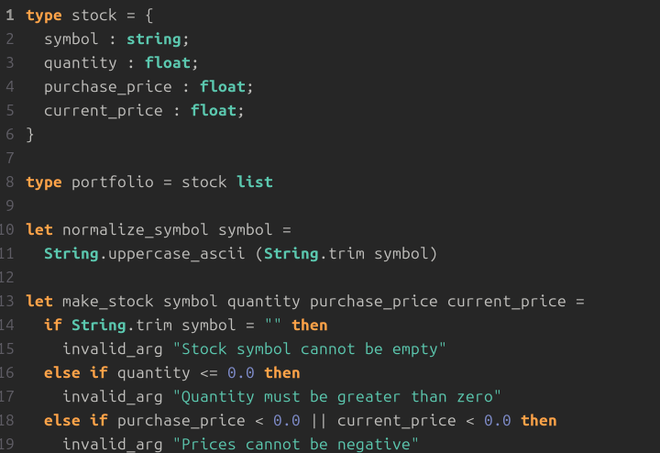
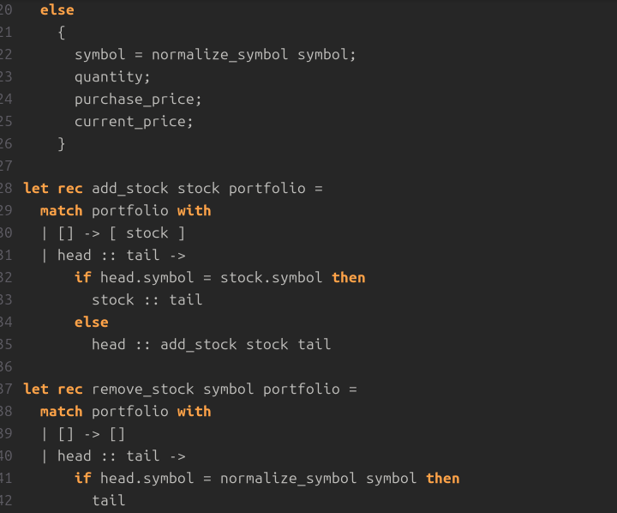
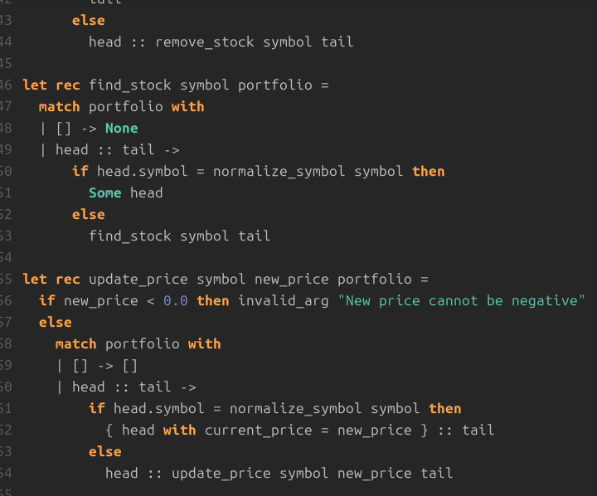
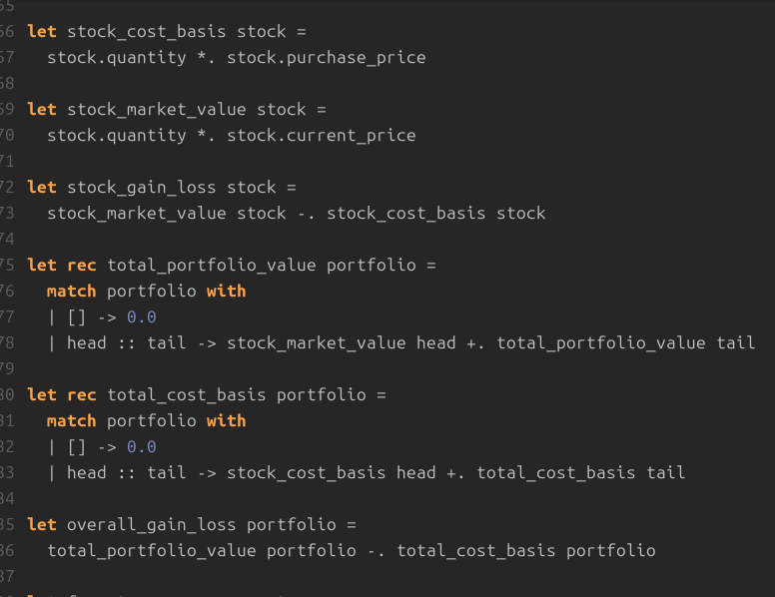
Issues Faced and Remedies.
At the stage of development, there were some typical peculiarities of OCaml that created certain difficulties that were to be overcome by means of careful decisions. The initial significant difficulty was due to the default immutable nature of OCaml: early efforts to change the price of a stock in place could not even compile since lists and records are immutable. The answer was to have the record with syntax within the recursive updateprice function which would make a new copy of the changed stock and leave the remainder of the list intact. This not only met the requirement of immutability, but also made the code simpler to reason and understand.

The second difficulty was the explicit requirement of the project in using recursion rather than loops. The first non-tail-recursive implementations would raise compiler warnings of possible stack overflow on large portfolios. The workaround was to redesign all list-processing functions in a manner that the recursive call is made in tail position, which the compiler of OCaml would then automatically make into constant-space loops. This change ensured the efficiency as it ensured that it was readable.

The third challenge was that of type safety in the case of missing stocks. This would have caused exceptions or wrong behavior without good design because trying to delete or modify something that does not exist. In these instances return of the unchanged portfolio and pattern matching on the returned option type of findstock made all operations total and exception free. The exhaustive checking provided by the compiler was to ensure that all the possible cases (empty list or symbol not found) were explicitly covered.

Lastly, there was the need to make the currency output consistent and professional looking. Hand concatenation of dollar signs and two-decimal formatting would have been error prone. Repeated use of the duplication of the single formatcurrency function through the use of the Printf.sprintf method of formatting dismissal was removed by using a single formatcurrency function and ensured that the same format was used throughout the application. Having managed to overcome these hurdles despite attentively reading the OCaml manual and stepwise testing with the toplevel interpreter, proved to enhance the final implementation and the general knowledge of functional programming idioms.

Test Cases
A thorough testing process was conducted to check each of the functions and to check both normal operation and all the necessary edge cases. First, the valid stock generation was tested by the successful generation of stocks like AAPL with quantity 10, purchase price 150 and the current price 185; the generated record was projected as expected and generated the appropriate gain on a per-stock basis of 350. After that invalid input handling was tested by making deliberate attempts to pass empty symbols, zero or negative values and negative prices; in every attempt, the documented Invalidargument exceptions were rightfully raised with accurate messages.

Portfolio maneuvering tests took place. Stock additions to the empty list created a one-portfolio as anticipated. The appropriate input of a duplicate symbol as a replacement of the previous entry maintained the uniqueness and did not lead to the formation of duplicates. The deletion of a symbol that does not exist (such as the GOOG in the demo portfolio) did not affect the original list in any way. Equally, trying to modify the price of a symbol that was not available gave the portfolio a non-modified version and an error.
Cases in which the portfolio is empty as an edge case were confirmed explicitly: each of the total value and the overall gain/loss was equal to 0.0, and viewportfolio returned the obvious message that it was an empty portfolio. Lastly, the entire demonstration was run in end to end mode; execution of printsummary (demoportfolio ()) gave the desired output with the stock-by-stock details, total portfolio value of 5500.00 with an overall profit of 580.00. All the eight types of test cases successfully passed indicating that the implementation can satisfy all the requirements of functionality and safety.
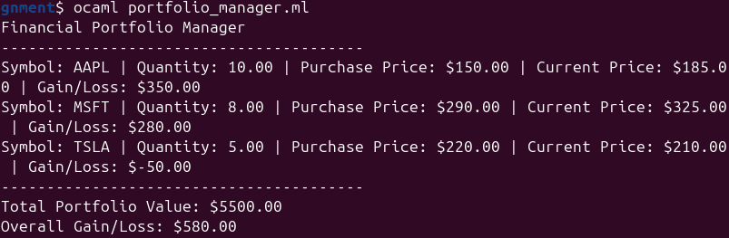
Conclusion
The finished Financial Portfolio Manager meets all the specifications of the project specification and demonstrates the beauty of the OCaml functional style. The application runs in a correct state, with no side effects, and no mutable state, as a result of immutable data, pattern matching exhaustively and tail-recursive processing. The syntax, recursion, and type system problems were solved in a systematic manner, which leads to code being concise, maintainable, and prepared to be enhanced in future, e.g. persistence or command line interface. The project has offered a great experience of working with the power of the OCaml type system and the best practice in functional programming. The last deliverable which is code repository, test cases and this report all fit the submission requirement and showcase a solution of professional level.

References
Leroy, X., Doligez, D., Frisch, A., Garrigue, J., Rémy, D., & Vouillon, J. (2012). The OCaml system release 4.00. Documentation and user’s manual, Projet Gallium, INRIA (Jul. 2012).
Madhavapeddy, A., & Minsky, Y. (2022). Real World OCaml: Functional programming for the masses. Cambridge University Press.

